**Universitatea Tehnică a Moldovei**

**RAPORT**

**Lucrarea de laborator nr.1**

**Instrumente de testare. Selenium.**

**A efectuat Druța Mihai**

**st. gr. FI-161**

**A verificat Popa D.**

**Chișinău 2018**

**Link-ul către repositoriul github:** https://github.com/MihaiDruta/TSLab1

**1.Utilizarea extensiei Selenium pentru browser-ul Chrome.**

Am verificat logarea prin introducerea unor date incorecte, apoi a unor date corecte.

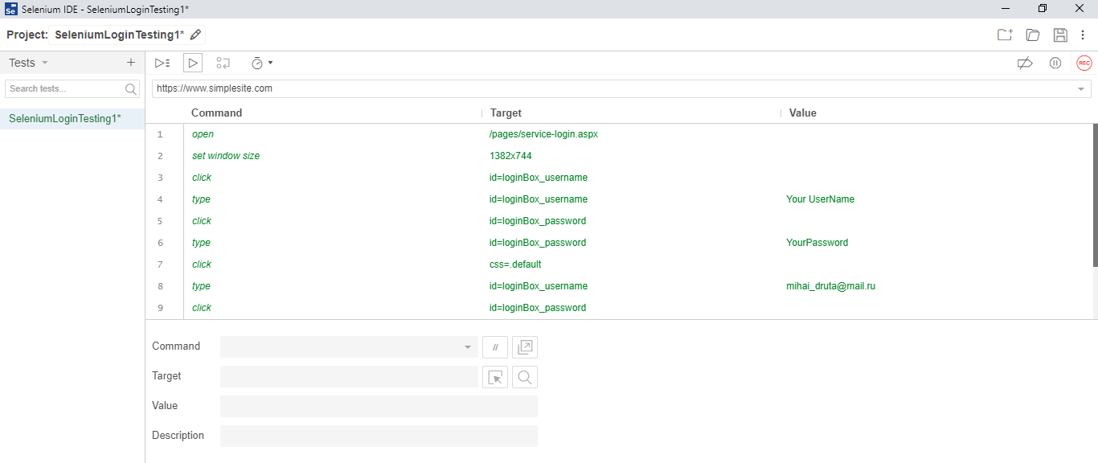

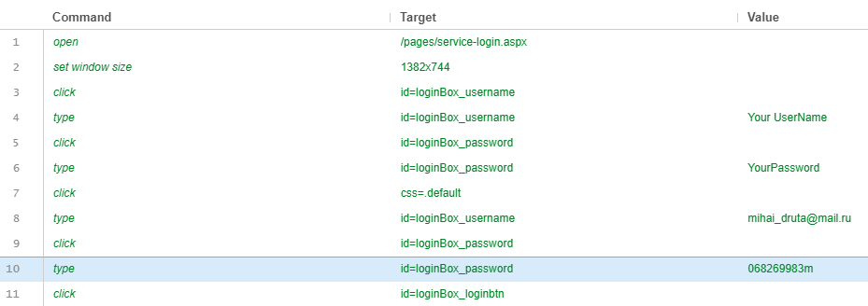

Pașii efectuați de Selenium IDE la executarea testului.

**Running 'SeleniumLoginTesting1'**1.open on /pages/service-login.aspx OK2.setWindowSize on 1382x744 OK3.click on id=loginBox_username OK4.type on id=loginBox_username with value Your UserName OK5.click on id=loginBox_password OK6.type on id=loginBox_password with value YourPassword OK7.click on css=.default OK8.type on id=loginBox_username with value [mihai_druta@mail.ru](mailto:mihai_druta@mail.ru) OK9.click on id=loginBox_password OK10.type on id=loginBox_password with value 068269983m OK11.click on id=loginBox_loginbtn OK  
**'SeleniumLoginTesting1' completed successfully**

**2.Crearea testelor utilizînd IntellijIDEA și Selenium WebDriver**

package login;

import java.util.concurrent.TimeUnit;

import org.openqa.selenium.By;

import org.openqa.selenium.WebDriver;

import org.openqa.selenium.chrome.ChromeDriver;

public class Login1 {

public static void main(String[] args) {

System.setProperty("webdriver.chrome.driver", "C:\\chromedriver.exe");

WebDriver driver = new ChromeDriver();

driver.manage().timeouts().implicitlyWait(10, TimeUnit.SECONDS);

driver.get("https://www.simplesite.com/pages/service-login.aspx");

driver.manage().window().maximize();

driver.findElement(By.id("loginBox_username")).sendKeys(" YOUR USER NAME");

driver.findElement(By.id("loginBox_password")).sendKeys("YOUR PASSWORD");

driver.manage().timeouts().implicitlyWait(60, TimeUnit.SECONDS);

driver.findElement(By.id("loginBox_loginbtn")).click();

driver.findElement(By.id("loginBox_username")).clear();

driver.findElement(By.id("loginBox_username")).sendKeys("mihai_druta@mail.ru");

driver.findElement(By.id("loginBox_password")).sendKeys("068269983m");

driver.manage().timeouts().implicitlyWait(60, TimeUnit.SECONDS);

driver.findElement(By.id("loginBox_loginbtn")).click();

driver.close();

}

}

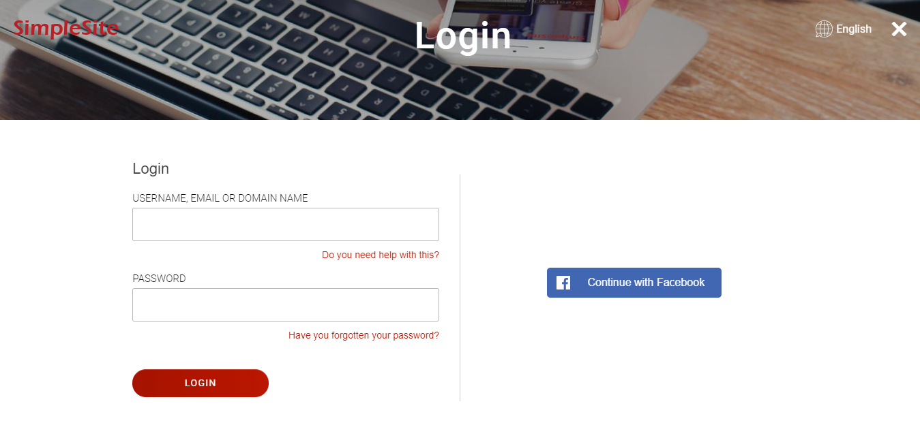

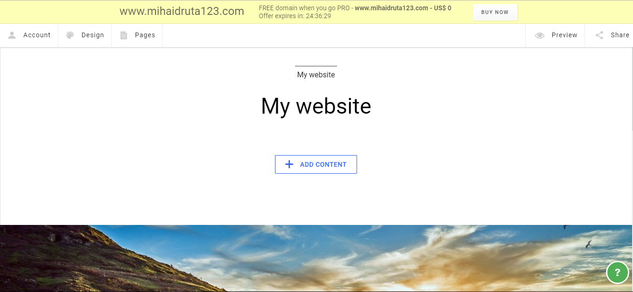

**Concluzie:**

Efectuînd această lucrare de laborator am făcut cunoștință cu Selenium IDE. Am efectuat cazuri de testare pentru logare pe un site. Am introdus date corecte și incorecte pentru a observa comportamentul site-ului in timpul testelor.